Q.1 | Answer any 4 out of the given 6 questions on Employability Skills (1x4=4 marks)
i. | (d) This is Abdul’s house.
ii. | (b) simple words
iii. | (a) Global Positioning System
iv. | (b) Bargaining
v. | (b) Dragging
vi. | (d) Email address of the person you are sending the mail to

Q.2 | Answer any 5 out of the given 6 questions (1x 5= 5 marks)
i. | c. Data Security
ii. | c. Computer Vision
iii. | - Python is a case-sensitive language, meaning Variable and variable are not the same
iv. | a. Data Management System
v. | b. Data Acquisition
vi. | c. Discrete Data

Q.3 | Answer any 5 out of the given 6 questions (1x 5= 5 marks)
i. | d. Thinking about the benefits stakeholders would get from the solution.
ii. | b. The proper handling of sensitive data, including personal data, to meet regulatory requirements.
iii. | c. The rules are defined by the developer, and the machine follows these instructions statically.
iv. | - Relational (Comparison) operators
v. | d. Data Exploration

vi. | c. Natural Language Processing
Q.4 | Answer any 5 out of the given 6 questions (1x 5= 5 marks)
i. | d. Continuous Data
ii. | a. True
iii. | b) float
iv. | b) Processed data that is meaningful

v. | c. Graphical
vi. | d. Data Interpretation
Q.5 | Answer any 5 out of the given 6 questions (1x 5= 5 marks)
i. | b. Understand, work with, and talk about data.
ii. | c. The guiding principles to decide what is good or bad.
iii. | c) then

iv. | b) name_1
v. | c. Line Graphs
vi. | b. Data Acquisition
SECTION B: SUBJECTIVE TYPE QUESTIONS
Answer any 3 out of the given 5 questions on Employability Skills (2x3=6 marks) Answer each question in 20 – 30 words.
Q.6 | Give examples of any four common signs used for visual communication.  Four common signs used for visual communication are:  - Traffic Signals/Lights: Red, yellow, and green lights convey stop, slow down, and go.  - Stop Sign: A red octagon that visually communicates the order to stop.  - No Smoking Sign: A circle with a cigarette and a line through it, communicating a prohibition.  - Danger/Warning Signs: Symbols like a skull and crossbones or an exclamation mark inside a triangle to communicate a hazard. | 2
Q.7 | Describe the functions of at least 5 types of keys.  • Alphabet Keys (A-Z): Used to type letters and words.  • Numeric Keys (0-9): Used to type numbers, often arranged in a row or a separate numeric keypad.  • Enter Key: Used to execute a command, submit data, or move the cursor to the next line.  • Spacebar: Used to insert a space between characters or words.  • Shift Key: Used to type capital letters and the upper symbols shown on certain keys (like !, @, #). | 2
Q.8 | List any four characteristics of entrepreneurship.  • Creativity and Innovation  - Entrepreneurs think of new ideas, products, or better ways of doing things.  • Risk-taking  - They are willing to take calculated risks to start and grow a business.  • Leadership  - Entrepreneurs guide and motivate others to achieve business goals.  • Decision-making Ability  - They can make quick and effective decisions when needed. | 2
Q.9 | Write one sentence of each type—statement, question, exclamatory and order.  • Statement (Declarative): The exam will finish in two hours.  • Question (Interrogative): Did you finish studying the AI project cycle?  • Exclamatory: That is a great score!  • Order (Imperative): Please read the instructions carefully. | 2
Q.10 | Describe the functions of a mouse.  • Pointing  - Helps you move the pointer (cursor) on the screen to select or highlight items.  • Clicking  - Single-click: Selects an item.  - Double-click: Opens files, folders, and applications.  • Right-clicking  - Opens a shortcut menu with additional options.  • Dragging and Dropping  - Allows you to move files or objects by clicking, holding, and moving the mouse.  • Scrolling  - The scroll wheel helps move up and down on a page or document. | 2

Answer any 4 out of the given 6 questions in 20–30 words each (2 x4 =8 marks)
Q.11 | What are data features, and name the two types of features required in AI models?  Data features are the characteristics or properties of the data. They describe each piece of information in a dataset.  Independent features are the input to the model—they're the information we provide to make predictions.  Dependent features, on the other hand, are the outputs or results of the model—they're what we're trying to predict. | 2
Q.12 | Explain the six stages of the AI Project Cycle.  • Problem Scoping: Define the problem and set the goal.  • Data Acquisition: Gather the necessary data.  • Data Exploration: Analyze and visualize the data for patterns.  • Modelling: Choose or build the appropriate AI model.  • Evaluation: Test and refine the model's performance.  • Deployment: Implement the final model in a real-world setting. | 2
Q.13 | Explain the primary distinction between Data Processing and Data Interpretation.  Data Processing  Data processing helps computers understand raw data.  Use of computers to perform different operations on data is included under data processing.  Data Interpretation  It is the process of making sense out of data that has been processed.  The interpretation of data helps us answer critical questions using data. | 2
Q.14 | Write a Python program to calculate the simple interest if principle amount=2000, rate of interest=4.5, Time period is 10 years.  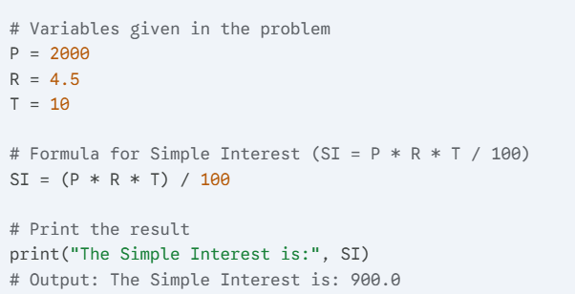 | 2
Q.15 | Explain the primary purpose of the 'Who' and 'Why' blocks within the 4Ws Problem Canvas during the Problem Scoping stage.  • Who Block: Identifies the stakeholders—the people who are affected by the problem and those who will benefit from the AI solution.  • Why Block: Determines the benefits or advantages the stakeholders will gain from solving the problem, setting the ultimate goal for the AI project. | 2
Q.16 | List two methods of Data Collection used for Quantitative Data Interpretation.  - Interviews: Quantitative interviews play a key role in collecting information.  - Polls: A poll is a type of survey that asks simple questions to respondents. Polls are usually limited to one question.  - Observations: Quantitative data can be collected through observations in a particular time period  - Longitudinal Studies: A type of study conducted over a long time  - Survey: Surveys can be conducted for a large number of people to collect quantitative data. | 2
Answer any 3 out of the given5 questions in 50–80 words each (4x3=12 marks)
Q.17 | Write a python program to calculate the total and average marks of 3 subjects.  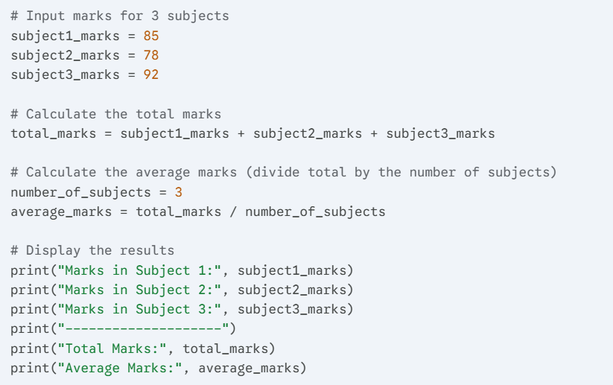 | 4
Q.18 | Distinguish between the Rule-Based Approach and the Learning-Based Approach in AI Modelling. | 4
  Rule-Based Approach | Learning-Based Approach
  Rule Based Approach refers to the AI modelling where the relationship or patterns in data are defined by the developer. | Learning Based Approach refers to the AI modelling where the relationship or patterns in data are not defined by the developer.
  The machine follows the rules or instructions mentioned by the developer, and performs its task accordingly. | In this approach, random data is fed to the machine and it is left on the machine to figure out patterns and trends out of it.
  This approach uses labelled dataset. | This approach uses unlabelled dataset.
Q.19 | Explain the different visual representations in data exploration.  • Bar Graphs: Used to compare discrete categories. They use rectangular bars whose lengths are proportional to the values they represent. ⁴²  • Line Graphs: Show how a quantity changes over a continuous period of time by connecting various data points. They are excellent for showing trends. ⁴³  • Pie Charts: Display parts of a whole, where the entire circle represents $100\%$, and each slice represents a category's percentage contribution.  • Histograms: Similar to bar graphs, but they show the distribution of continuous data, grouping data into 'bins' or ranges.  • Scatter Plots: Used to show the relationship or correlation between two different variables (e.g., weight vs. height) by plotting individual data points. | 4
Q.20 | Explain data pyramid with the diagram.  - Data Pyramid is made of different stages of working with data.  - Data is available in a raw form. Data in this form is not very useful.  - Data is processed to give us information about the world.  - Information about the world leads to knowledge of how things are happening.  - Wisdom allows us to understand why things are happening in a particular way.  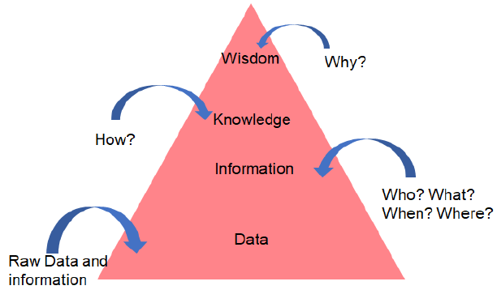 | 4
Q.21 | Differentiate between Artificial Intelligence, Machine learning and Deep learning.  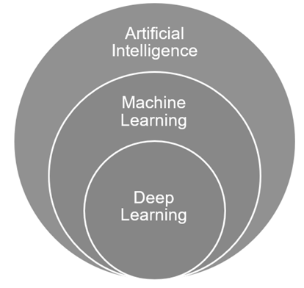 | 4
  Artificial Intelligence | Machine learning | Deep Learning
  AI represents stimulated intelligence in machines. | ML is the practice of getting machines to make decisions without being programmed. | It is artificial neural network to solve the complex problems.
  AI is a subset of data science. | ML is the subset of AI and data science. | DL is the subset of AI , ML and data science.
  AI aims toward building machines that are capable to think like humans | ML aims to learn through data to solve problems. | DL aim to build neural network that automatically discover patterns for feature detection

